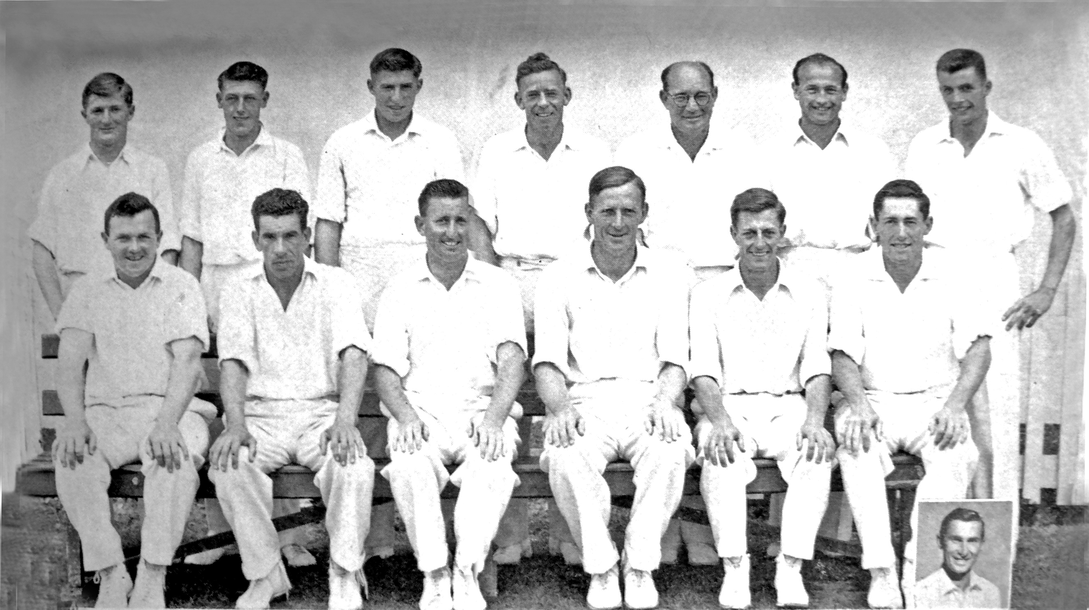

**Canterbury Representative Team 1959/60 Winners of the Plunket Shield**

**Back Row:** AF Rapley, JT Ward, RC Motz, JW Kiddey, RT Hunt, PGZ Harris, CR Nicholson

**Front Row:** K Thomson, SC Guillen, ME Chapple (captain), AR MacGibbon, BA Bolton, GT Dowling (Inset GD Alabaster)